What is Maven?

Maven is an application BUILD TOOL, Which is help to build a Java Application and also which is a project management tool.

Download

<https://maven.apache.org/download.cgi>

Installation

Install JDK, set JAVA_HOME and update path variable

Extract the downloaded zip

Maven Home M2_HOME

Maven Path

Maven version

How to configure maven in eclipse?

Help- install new soft

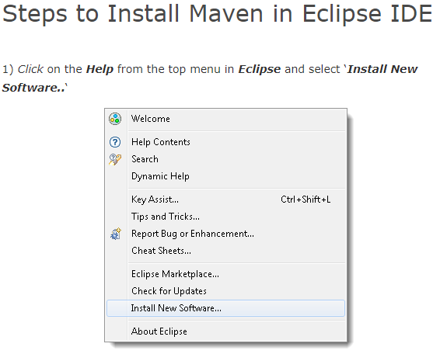

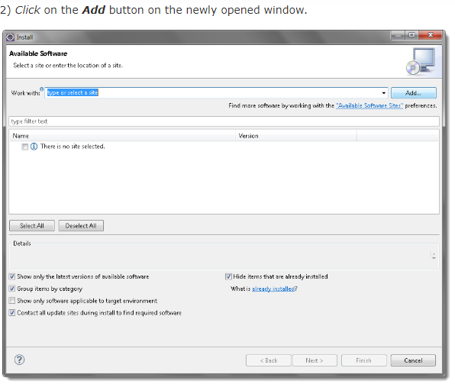

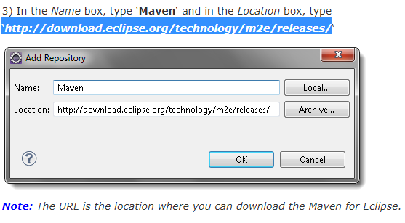

http://download.eclipse.org/technology/m2e/releases/

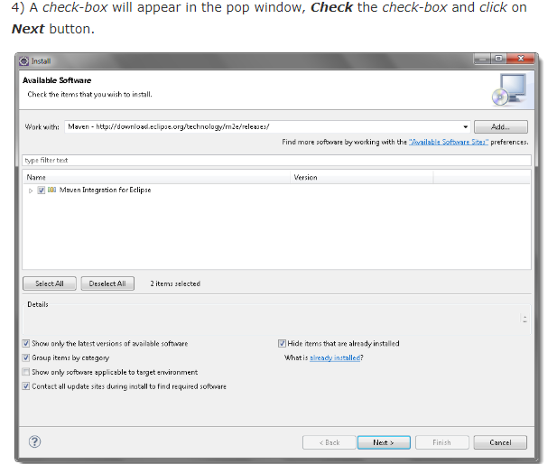

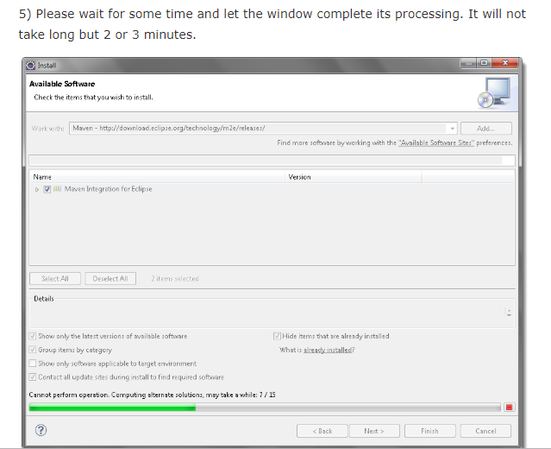

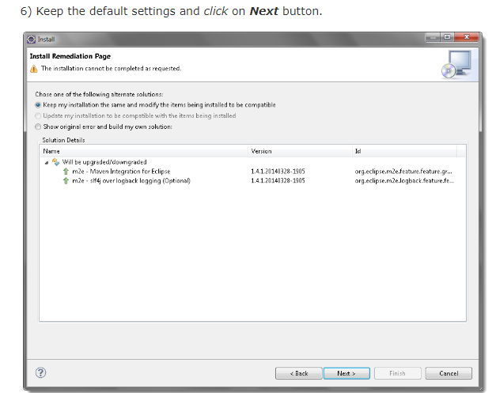

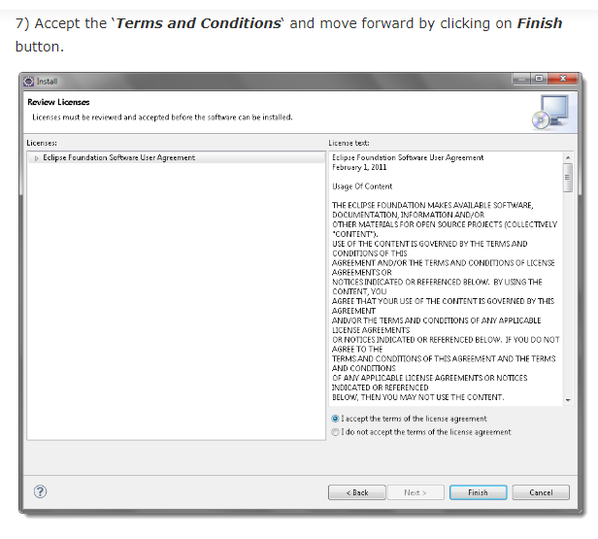

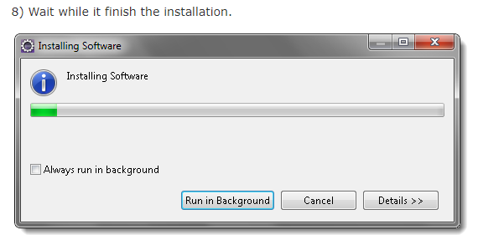

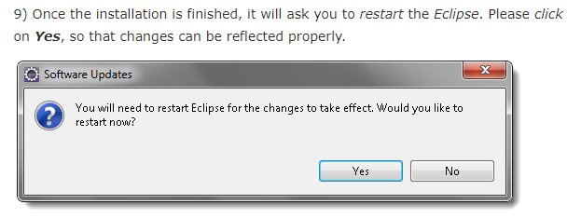

5)How to create maven project in Eclipse?

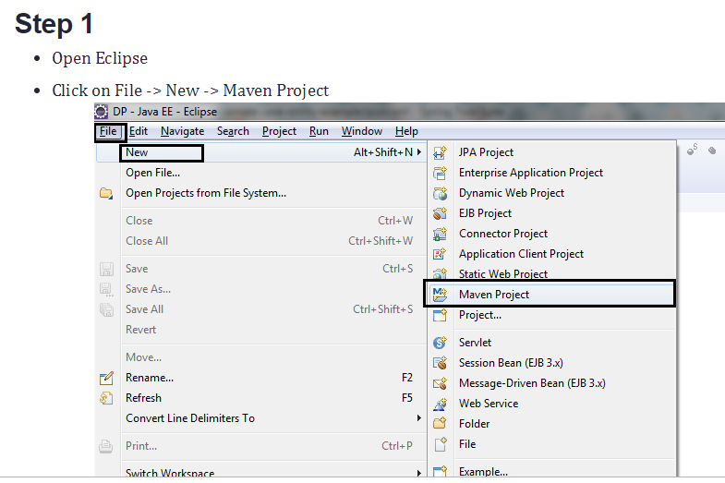

*Open Eclipse and click on new then it will shown maven project and select it.

*After selecting it will show like this below

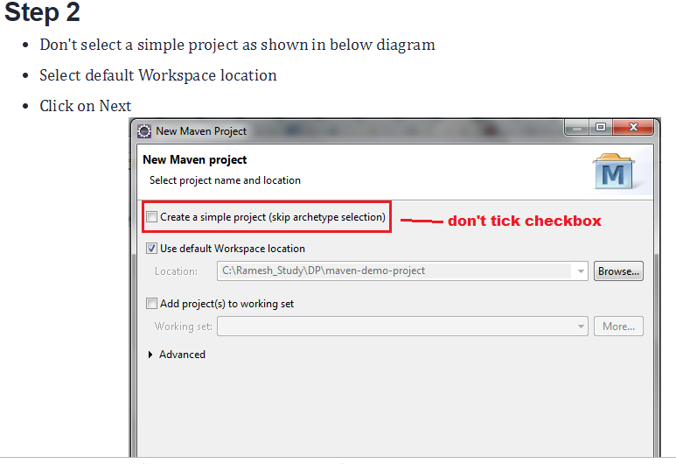

*Then create default work space location.

*Click on next, Then type “web” in filter Box, it will Show like this above.

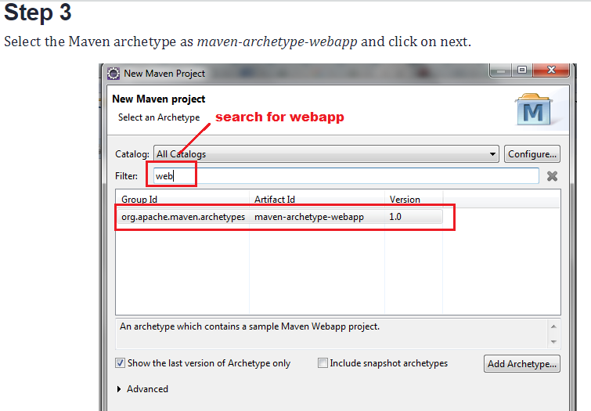

*Click on next.

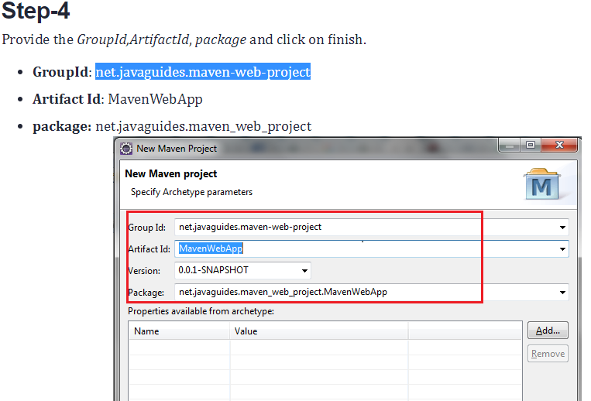

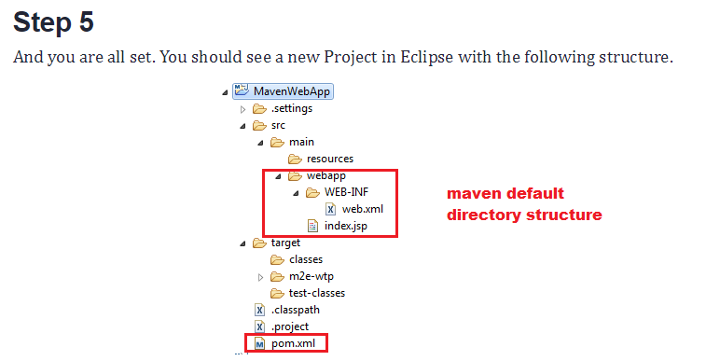

Cvs,sen,git,git hub-------tools----------versioning systems

<?xmlversion=*"1.0"*encoding=*"UTF-8"*?>

<projectxmlns=*"http://maven.apache.org/POM/4.0.0"*xmlns:xsi=*"http://www.w3.org/2001/XMLSchema-instance"*xsi:schemaLocation=*"http://maven.apache.org/POM/4.0.0 http://maven.apache.org/xsd/maven-4.0.0.xsd"*>

<!--

~ Licensed to the Apache Software Foundation (ASF) under one or more

~ contributor license agreements. See the NOTICE file distributed with

~ this work for additional information regarding copyright ownership.

~ The ASF licenses this file to You under the Apache license, Version 2.0

~ (the "License"); you may not use this file except in compliance with

~ the License. You may obtain a copy of the License at

~

~ http://www.apache.org/licenses/LICENSE-2.0

~

~ Unless required by applicable law or agreed to in writing, software

~ distributed under the License is distributed on an "AS IS" BASIS,

~ WITHOUT WARRANTIES OR CONDITIONS OF ANY KIND, either express or implied.

~ See the license for the specific language governing permissions and

~ limitations under the license.

-->

<modelVersion>4.0.0</modelVersion>

<parent>

<groupId>org.apache.logging.log4j</groupId>

<artifactId>audit-sample-parent</artifactId>

<version>1.0.0-SNAPSHOT</version>

</parent>

<groupId>org.apache.logging.log4j</groupId>

<packaging>jar</packaging>

<description>Audit Logging Service</description>

<dependencyManagement>

<dependencies>

<dependency>

<groupId>org.springframework.boot</groupId>

<artifactId>spring-boot-dependencies</artifactId>

<version>${spring.boot.version}</version>

<type>pom</type>

<scope>import</scope>

</dependency>

</dependencies>

</dependencyManagement>

<dependencies>

<dependency>

<groupId>org.apache.logging.log4j</groupId>

<artifactId>log4j-catalog-api</artifactId>

<version>${log4j-audit.version}</version>

</dependency>

<dependency>

<groupId>org.apache.logging.log4j</groupId>

<artifactId>audit-service-war</artifactId>

<type>war</type>

<version>${project.version}</version>

</dependency>

<dependency>

<groupId>org.springframework.boot</groupId>

<artifactId>spring-boot-starter-web</artifactId>

<exclusions>

<exclusion>

<groupId>org.springframework.boot</groupId>

<artifactId>spring-boot-starter-logging</artifactId>

</exclusion>

</exclusions>

</dependency>

<dependency>

<groupId>org.springframework.boot</groupId>

<artifactId>spring-boot-starter-thymeleaf</artifactId>

</dependency>

<dependency>

<groupId>org.springframework.boot</groupId>

<artifactId>spring-boot-devtools</artifactId>

<optional>true</optional>

</dependency>

<dependency>

<groupId>org.springframework.boot</groupId>

<artifactId>spring-boot-starter-log4j2</artifactId>

</dependency>

<dependency>

<groupId>org.springframework.boot</groupId>

<artifactId>spring-boot-starter-actuator</artifactId>

</dependency>

<dependency>

<groupId>org.springframework.boot</groupId>

<artifactId>spring-boot-starter-tomcat</artifactId>

</dependency>

<dependency>

<groupId>org.springframework.boot</groupId>

<artifactId>spring-boot-starter-test</artifactId>

<scope>test</scope>

</dependency>

<dependency>

<groupId>org.apache.logging.log4j</groupId>

<artifactId>log4j-api</artifactId>

</dependency>

<dependency>

<groupId>org.apache.logging.log4j</groupId>

<artifactId>log4j-core</artifactId>

</dependency>

<dependency>

<groupId>org.springframework</groupId>

<artifactId>spring-web</artifactId>

</dependency>

<dependency>

<groupId>org.springframework</groupId>

<artifactId>spring-webmvc</artifactId>

</dependency>

<dependency>

<groupId>org.springframework.data</groupId>

<artifactId>spring-data-rest-webmvc</artifactId>

</dependency>

<dependency>

<groupId>org.springframework.data</groupId>

<artifactId>spring-data-jpa</artifactId>

</dependency>

<dependency>

<groupId>org.modelmapper</groupId>

<artifactId>modelmapper</artifactId>

</dependency>

<dependency>

<groupId>org.modelmapper.extensions</groupId>

<artifactId>modelmapper-spring</artifactId>

</dependency>

<dependency>

<groupId>org.modelmapper.extensions</groupId>

<artifactId>modelmapper-jackson</artifactId>

</dependency>

<dependency>

<groupId>org.springframework.plugin</groupId>

<artifactId>spring-plugin-core</artifactId>

</dependency>

<dependency>

<groupId>org.springframework.plugin</groupId>

<artifactId>spring-plugin-metadata</artifactId>

</dependency>

<dependency>

<groupId>javax.servlet</groupId>

<artifactId>javax.servlet-api</artifactId>

<version>3.0.1</version>

<scope>provided</scope>

</dependency>

</dependencies>

<build>

<plugins>

<plugin>

<groupId>org.apache.maven.plugins</groupId>

<artifactId>maven-war-plugin</artifactId>

<version>3.1.0</version>

<configuration>

<failOnMissingWebXml>false</failOnMissingWebXml>

<overlays>

<overlay>

<groupId>org.apache.logging.log4j</groupId>

<artifactId>audit-service-war</artifactId>

<excludes>

<exclude>WEB-INF/lib/spring-*.jar</exclude>

</excludes>

</overlay>

</overlays>

</configuration>

<executions>

<execution>

<id>default-war</id>

<goals>

<goal>war</goal>

</goals>

<phase>package</phase>

</execution>

</executions>

</plugin>

<plugin>

<groupId>org.springframework.boot</groupId>

<artifactId>spring-boot-maven-plugin</artifactId>

<version>${spring.boot.version}</version>

<executions>

<execution>

<goals>

<goal>repackage</goal>

</goals>

</execution>

</executions>

</plugin>

</plugins>

</build>

</project>